Supramolecular assembly. Viruses

**Supramolecular assembly**

Supramolecular assemblies are a different type of large structure, related to macromolecules. In a supermolecular assembly, parts of the structure are held together by very strong interactions, but not necessarily by covalent bonds.

**What is a virus?**

A virus is a tiny, infectious particle that can reproduce only by infecting a host cell. Viruses "commandeer" the host cell and use its resources to make more viruses, basically reprogramming it to become a virus factory. Because they can't reproduce by themselves (without a host), viruses are not considered living. Nor do viruses have cells: they're very small, much smaller than the cells of living things, and are basically just packages of nucleic acid and protein.

**The structure of a virus**

Most viruses have different structures. But viruses do have a few key features in common. These include:

* A protective protein shell, or capsid.
* A nucleic acid genome made of DNA or RNA, tucked inside of the capsid. Because of this they’re devided into DNA and RNA viruses.
* A layer of membrane called the envelope (some but not all viruses).

**Virus capsids**

The capsid, or protein shell, of a virus is made up of many protein molecules. The proteins join to make units called capsomers, which together make up the capsid. Capsid proteins are always encoded by the virus genome, meaning that it’s the virus that provides instructions for making them.  Capsids come in many forms, but they often take one of the following shapes - icosahedral, filamentous, head-tail.

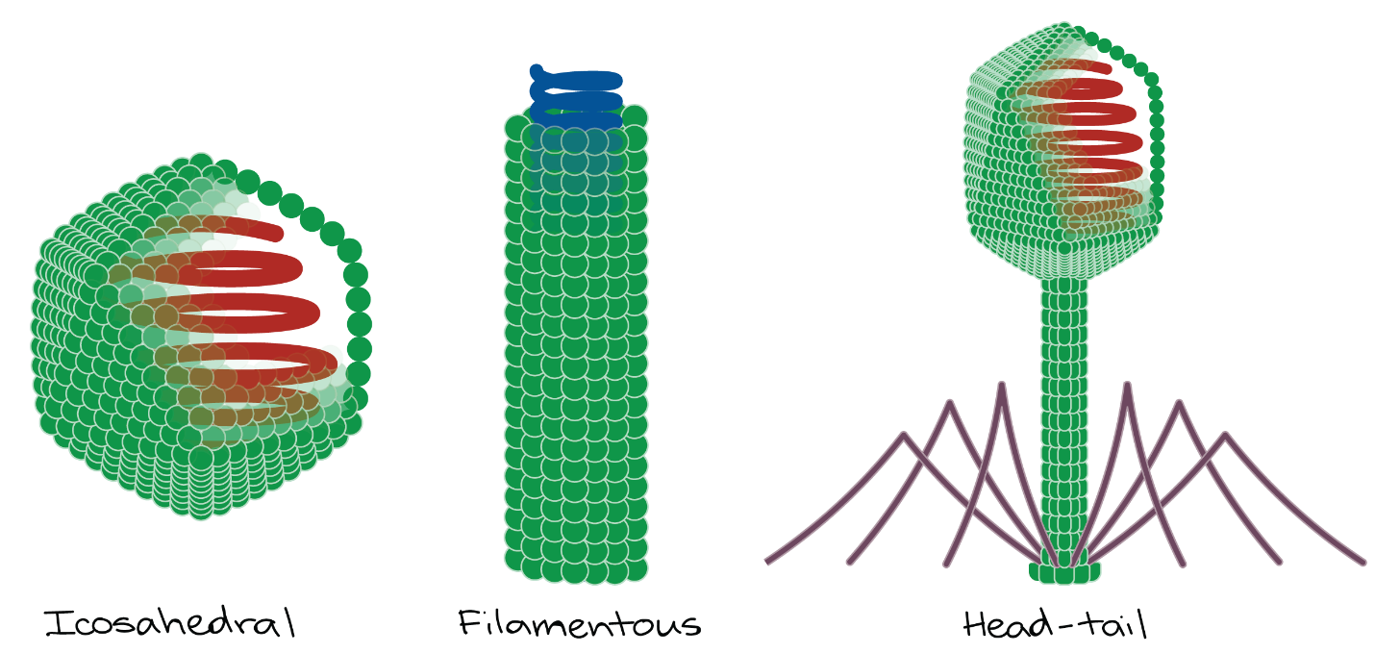

**Virus envelopes**

In addition to the capsid, some viruses also have an external lipid membrane known as an envelope, which surrounds the entire capsid. Envelopes contain proteins that are specified by the virus, which often help viral particles bind to host cells.

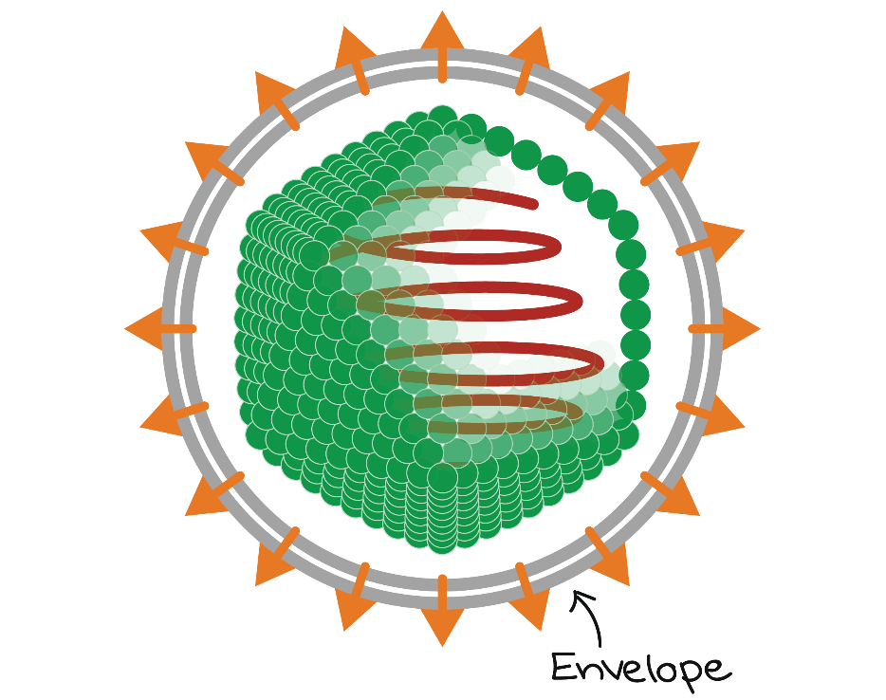

**Virus genomes**

All viruses have genetic material (a genome) made of nucleic acid. Viruses may use either RNA or DNA.

**What is a viral infection?**

At the microscopic scale, a viral infection means that many viruses are using your cells to make more copies of themselves. The viral lifecycle is the set of steps in which a virus recognizes and enters a host cell, "reprograms" the host by providing instructions in the form of viral DNA or RNA, and uses the host's resources to make more virus particles.

For a typical virus, the lifecycle can be divided into five broad steps (though the details of these steps will be different for each virus):

1. Attachment. Virus binds to receptor on cell surface.
2. Entry. Virus enters cell by endocytosis. In the cytoplasm, the capsid comes apart, releasing the RNA genome.
3. Replication and gene expression. The RNA genome is copied and translated into viral proteins using a host ribosome. The viral proteins produced include capsid proteins.
4. Assembly. Capsid proteins and RNA genomes come together to make new viral particles.
5. Release. The cell bursts, releasing the viral particles, which can then infect other host cells.